Meet the Teacher

Hi! My name is Mrs. Holly Gorham.
I began teaching at NFCS in 1998. These are a few
I have taught everything from 6th of my favorite things:
grade math to College Algebra.
I’m excited to teach your child and Drink: Starbucks Vanilla Latte
look forward to a great year! My Store: The Limited and Target
husband also works at NFCS. We Restaurant: Barnaby’s and
have two children; Emma is in 6th Carrabba’s
grade and Jack is in 4th grade. Singer: Steven Curtis Chapman
(love 80s music too!!)
Candy: Reese Cups and Twix
Hobby: Reading and Crafts
Movie: Breakfast at Tiffany’s
Flower: Gerber Daisy
Color: Blue
Dessert: cupcakes
Fast Food: Chick-Fil-A
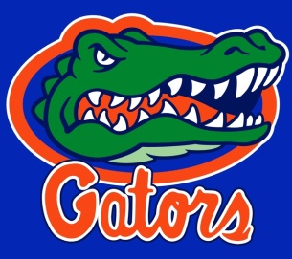
I attended NFCS and graduated in 1993. I attended FSU (even though I’m a devout Gator fan!!) and graduated in 1997 with a bachelor’s degree in mathematics education. In 2013, I received my master’s degree in mathematics education from Georgia State
University.

You can reach me the quickest by email:
hollygorham@nflchurch.com. You can also
call the school at 850-386-6327 x122
where you can leave me a message.

